MAGNESIUM MUSCLE RELAXATION
Unbuffered magnesium bisglycinate
Magnesium is one of the body's most important minerals.



Product description
Magnesium is necessary for a number of different functions in the body. Magnesium contributes to reducing fatigue and exhaustion, electrolyte balance, normal energy metabolism, normal functioning of the nervous system, normal muscle function, normal protein synthesis, normal psychological function, maintaining normal bone structure, maintaining normal teeth and has a role in the cell division process.

Magnesium is one of the building blocks of both bones and teeth. The skeleton contains 55–60% of the body's magnesium. In case of magnesium deficiency, the body can retrieve the mineral from the storage in the skeleton. It is important to get enough magnesium because it helps maintain normal bones and teeth.

Magnesium contributes to both normal muscle function and the normal function of the nervous system.

Magnesium is one of the most important minerals in the body. The body contains about 25 grams of magnesium. Over half is in the skeleton and teeth, the rest in the cells. Magnesium is important for the function of over 300 enzymes in the body.

Important functions of Magnesium
- Magnesium contributes to electrolyte balance
- Magnesium contributes to normal energy metabolism
- Magnesium contributes to the normal functioning of the nervous system
- Magnesium contributes to normal muscle function
- Magnesium contributes to normal protein synthesis
- Magnesium contributes to normal psychological function
- Magnesium plays a role in the cell division process

Supplemental facts and Ingredients
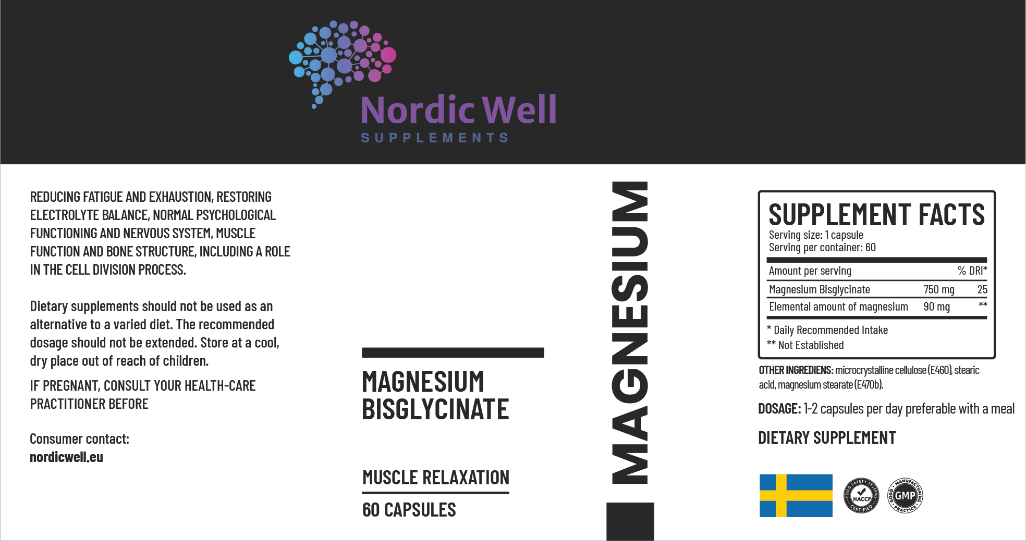
The recommended dose should not be exceeded. Dietary supplements should not be used as an alternative to a varied diet. Keep out of the reach of small children. Use it with care and speak with a doctor before taking it.
How to use
It is best taken in the evening, and to take 1-2 capsules per day, preferable with a meal or as recommended.

Magnesium in the form of magnesium bisglycinate is an easily absorbable form of magnesium and also mild on the stomach.

Take the MAGNESIUM together with the MULTI Multivitamin to obtain daily nutritional support for your body.



Warning

The recommended dose should not be exceeded. Dietary supplements should not be used as an alternative to a varied diet. Keep out of the reach of small children.

Storage
Dry at room temperature.

Magnesium sources
Magnesium is found in many foods, but especially in grain products and vegetables. Green leafy vegetables, nuts, bananas, legumes, dark chocolate, coffee and dairy products, potatoes, meat, shellfish and fish are also important sources.

Magnesium contributes to normal muscle function

Every movement we make requires magnesium because it contributes to both normal muscle function and normal nervous system function. The mechanism behind this effect is that magnesium contributes to the electrical voltage difference in the cell membranes of muscle and nerve cells. This tension difference controls the muscle dilatation, i.e. the muscle's ability to relax.

Magnesium contributes to maintaining normal bone structure
Magnesium is one of the building blocks of both bones and teeth. Skeleton contains 55–60% of the body's magnesium. In case of magnesium deficiency, the body can retrieve the mineral from the storage in the skeleton. It is important to get enough magnesium as it helps to maintain normal bones and teeth.

Magnesium bisglycinate
Magnesium bisglycinate is magnesium bound to the amino acid glycine (also occurs in the forms magnesium glycinate and magnesium triglycinate, but magnesium bisglycinate is the approved form within the EU).
The body has a relatively easy time identifying individual amino acids, and research has shown that the amino acid glycine is a molecule of choice when it comes to forming organic chelated minerals.
The body can easily identify glycine and then transport it through the intestinal mucosa into the body. Minerals chelated with glycine can be relatively easily taken up and then directly transported to the cell.
One reason for the good absorption is that part of the glycinate form is absorbed intact, probably via amino acid-dipeptide transport (Schuette SA, et.al.). This is partly because glycine improves the solubility of the entire complex, which improves bioavailability.
A double-blind study (Roussouw and Brummelen) also compared the bioavailability of magnesium bisglycinate with magnesium chloride. The results showed that magnesium bisglycinate partly had greater bioavailability and partly remained longer in the body.
Different forms of magnesium bisglycinate
In dietary supplements, there are usually two different forms of magnesium bisglycinate, unbuffered and buffered.
Unbuffered magnesium bisglycinate
Pure magnesium bisglycinate provides high absorption of magnesium but a lower proportion of elemental magnesium, up to a maximum of 11.8–12.0% (glycine is a large molecule, which provides less magnesium per weight and volume). This means that you have to take quite a lot of magnesium bisglycinate to get higher levels of magnesium.
Buffered magnesium glycinate
Magnesium bisglycinate in food supplements often appears with a slightly higher proportion of magnesium, 18–20%. That ingredient is then a so-called buffered variant with magnesium glycinate buffered with magnesium oxide.
The glycinate forms of magnesium are very good for restoring magnesium levels when you need to take relatively high amounts of magnesium for a long time, if you have an irritable bowel and/or if you are elderly.

Loose or sluggish in the stomach of magnesium?

An excess intake of magnesium can affect the intestinal mucosa. Too much magnesium oxide tends to produce slower stools (constipation) while citrate, sulfate and chloride forms of magnesium tend to produce loose stools (diarrhea).
Chelated, organically compound forms of magnesium, such as magnesium bisglycinate and magnesium citrate, are partly easier for the body to absorb, and partly have less impact on the gut compared to inorganic forms of magnesium, such as magnesium oxide.
The inorganic mineral forms, such as magnesium oxide, are for the most part the forms that occur in the bedrock. In the plant kingdom, minerals occur to a greater extent in organic forms. Simply put, the plants take up the inorganic minerals from the bedrock and bind them to various organic compounds to form, for example, magnesium bisglycinate and magnesium citrate.
Evolution has made it so that humans best absorb and use magnesium in the organic forms, while inorganic magnesium gives us a higher concentration of pure magnesium.






www.nordicwell.eu

Product by NordicWell Supplements



